Vinyl COLORS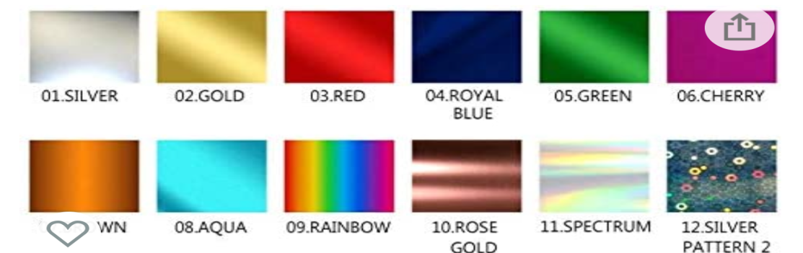
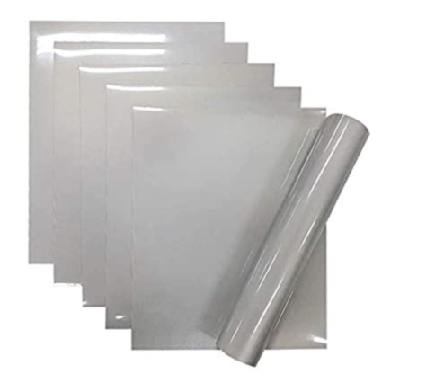

REFLECTIVE SILVER
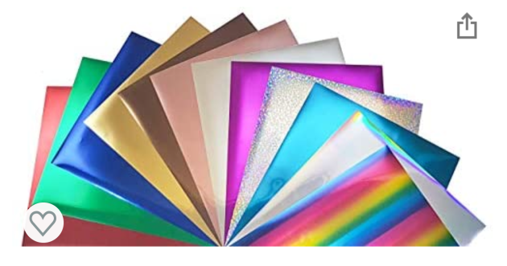
GOLD ROYAL BLUE SPECTRUM
ROSE GOLD AQUA SILVER PATTERN
SILVER BROWN
RED CHERRY
GREEN RAINBOW
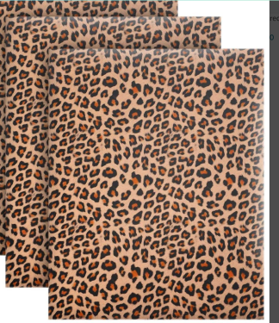 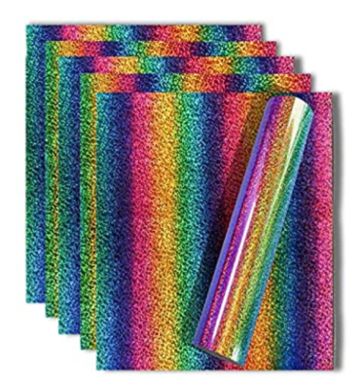HOLOGRAPHIC RAINBOW
LEOPARD VINLY

